电子版工作许可证领取操作指南
(Electronic Work Permit Collection Operation Guide)

- 手机下载“电子社保卡”APP
Download the "Electronic Social Security Card" APP on your mobile phone
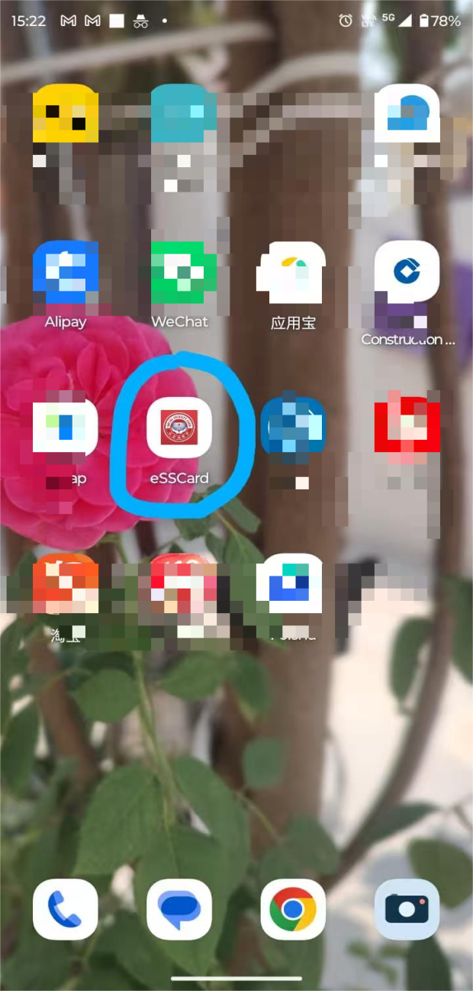
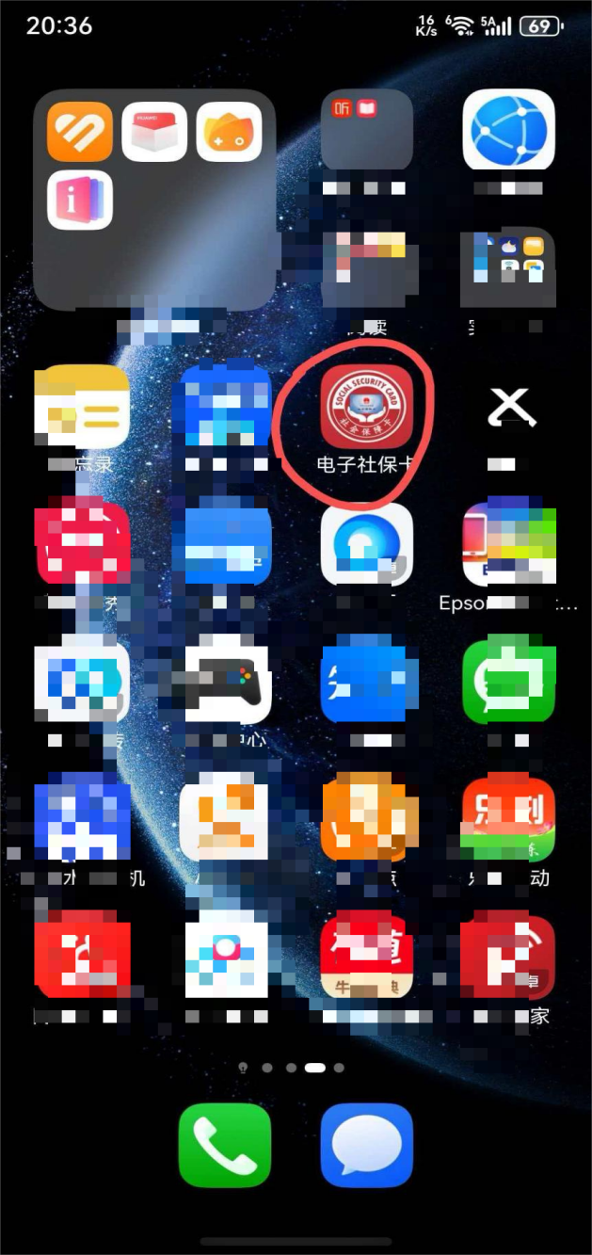

二、选择“登录” Select "Login"


三、选择“login portal for foreigner’s holding work permit”

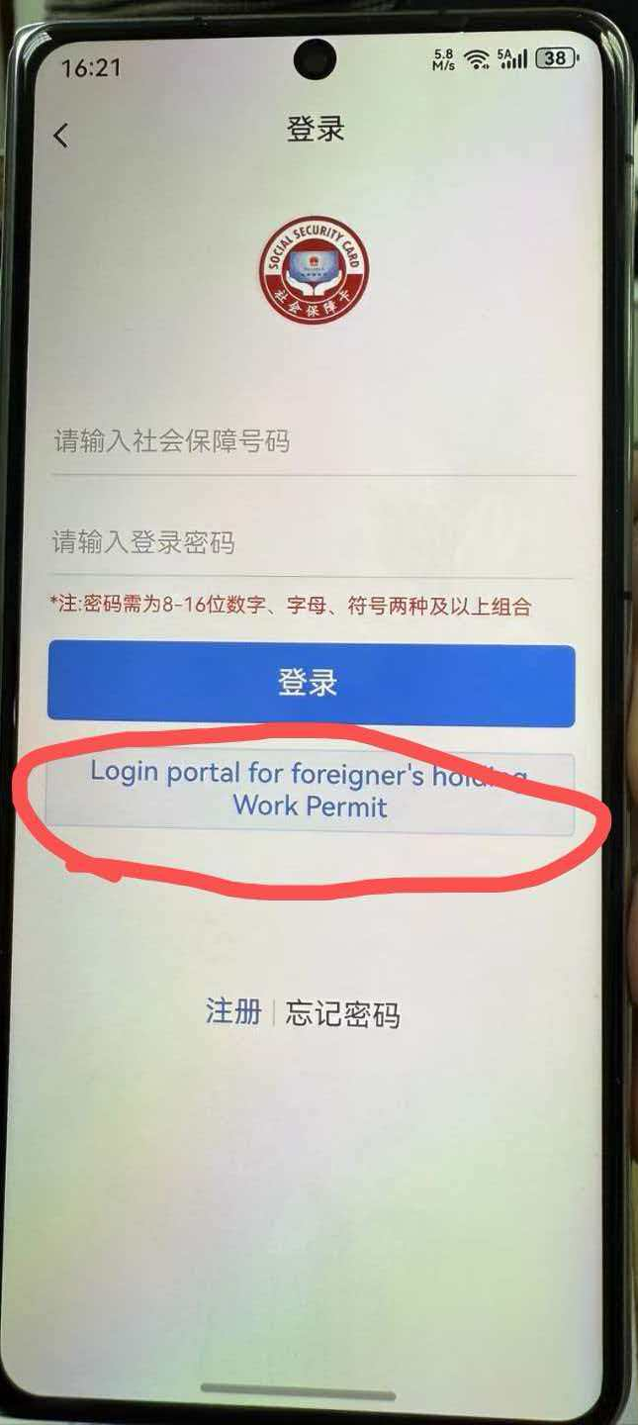

四、选择“registration”
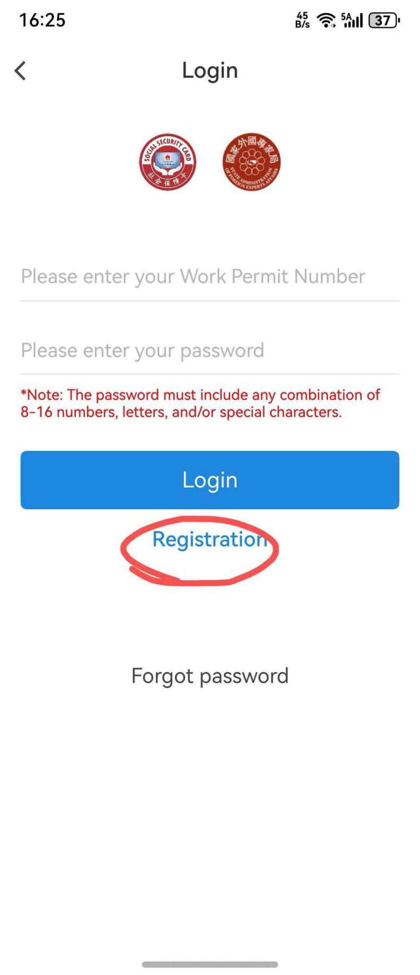

- 完成注册登录后，选择“work permit QR code”, 扫描“work permit QR code”，生成电子版工作许可信息，截屏打印，提供给出入境管理局办理居留许可使用。
After completing the registration and login, select "work permit QR code", scan the "work permit QR code", generate an electronic version of the work permit information, take a screenshot and print it, and provide it to the Exit-Entry Administration Bureau for use in applying for a residence permit.
